OPERATING SYSTEM

<https://www.interviewbit.com/operating-system-mcq/>

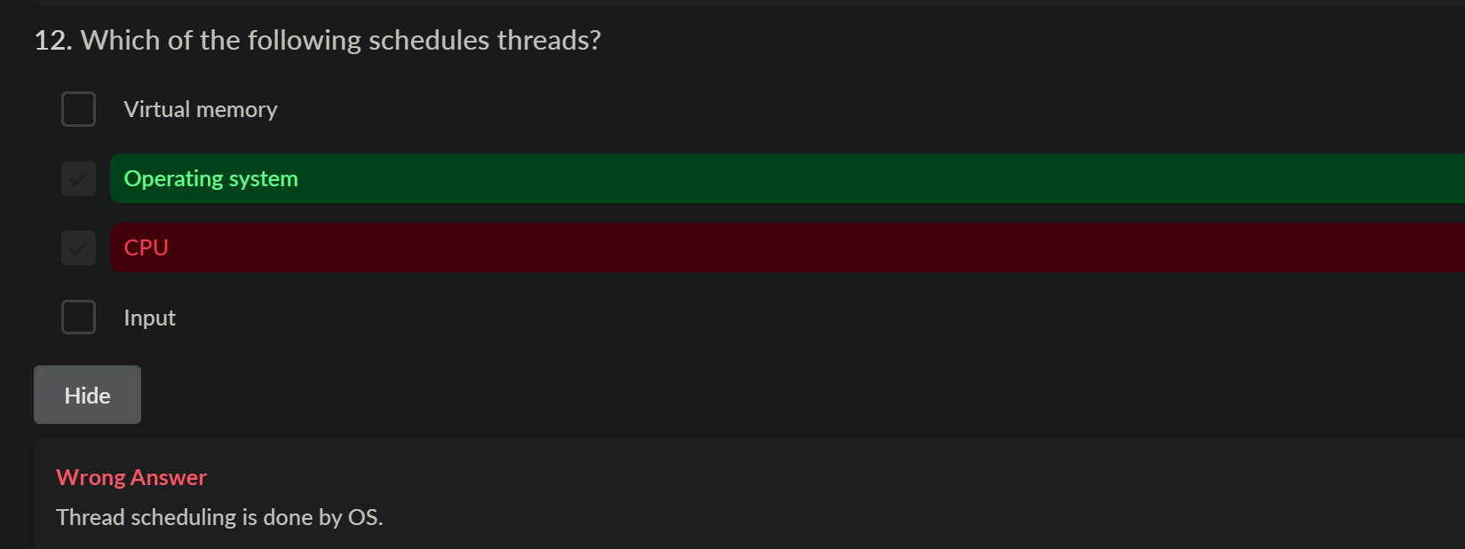

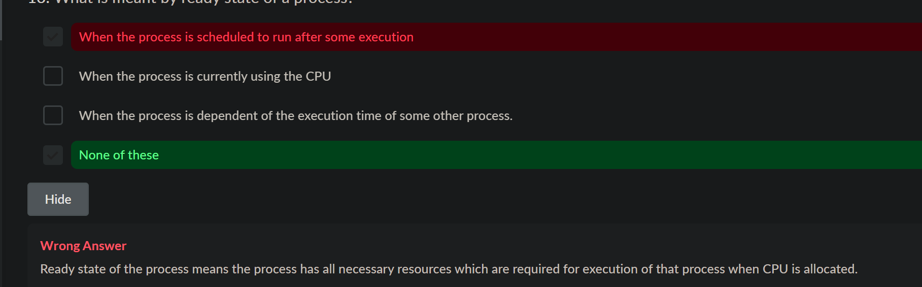





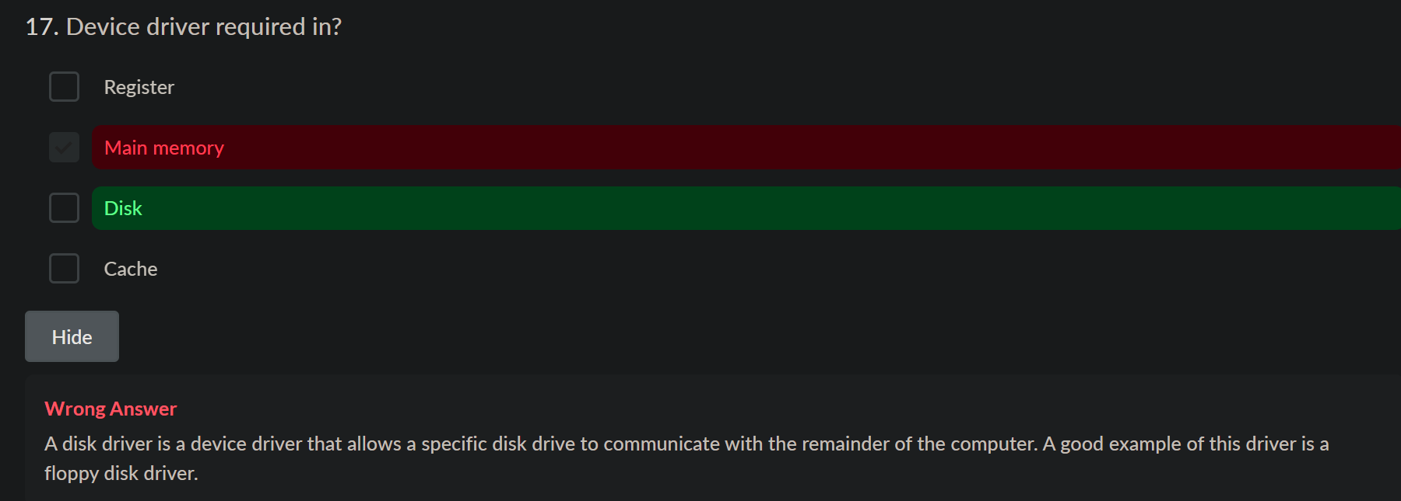

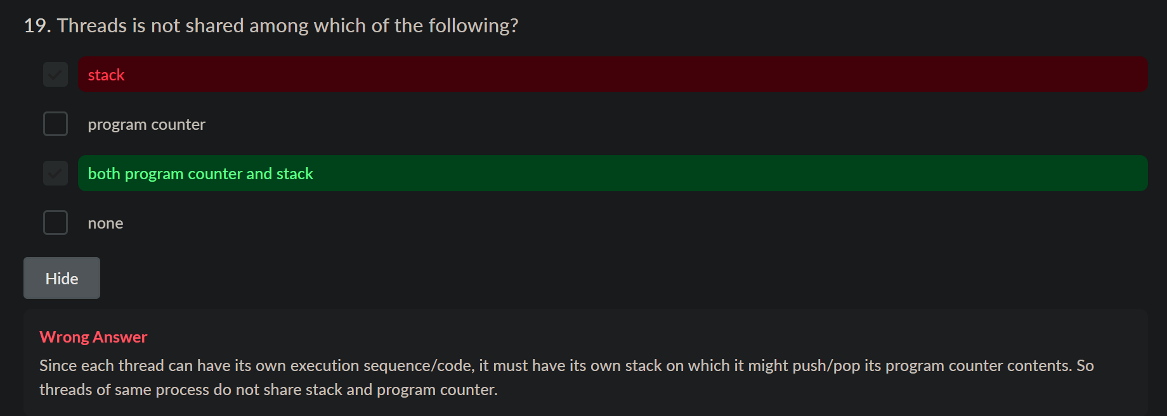

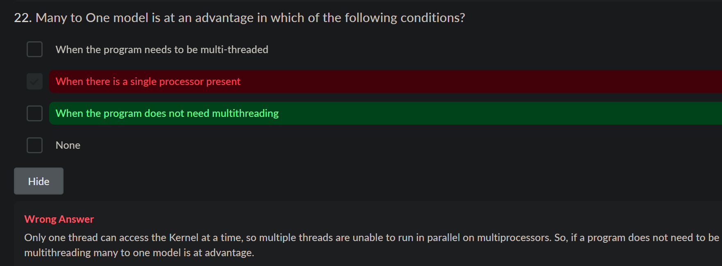

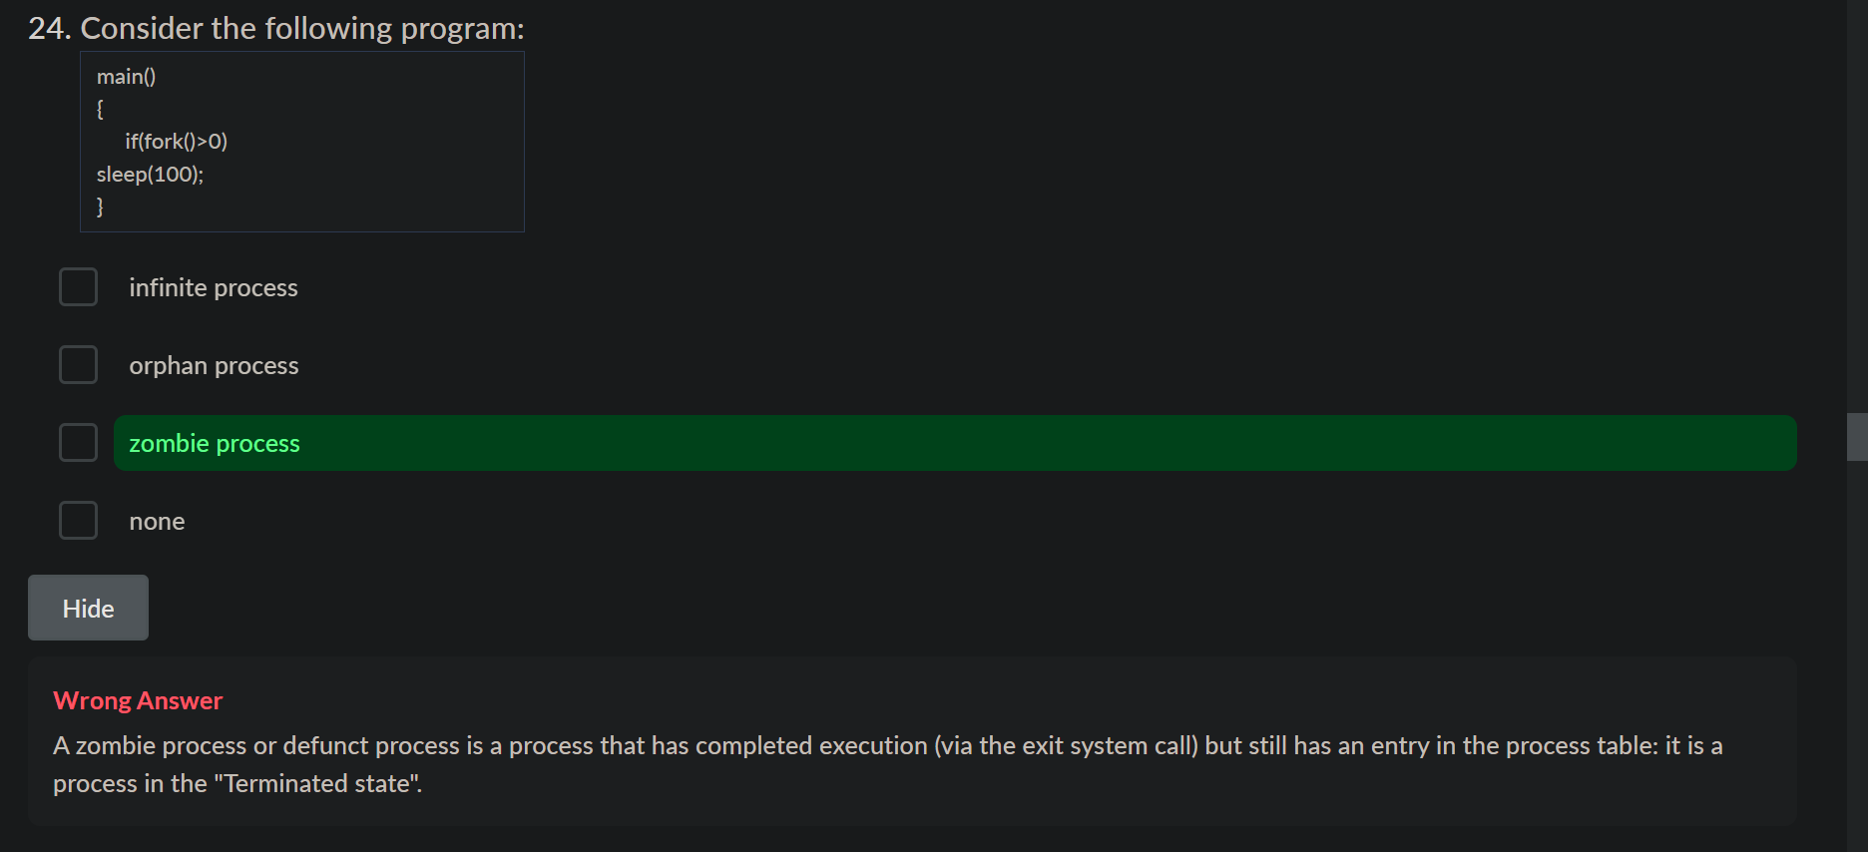

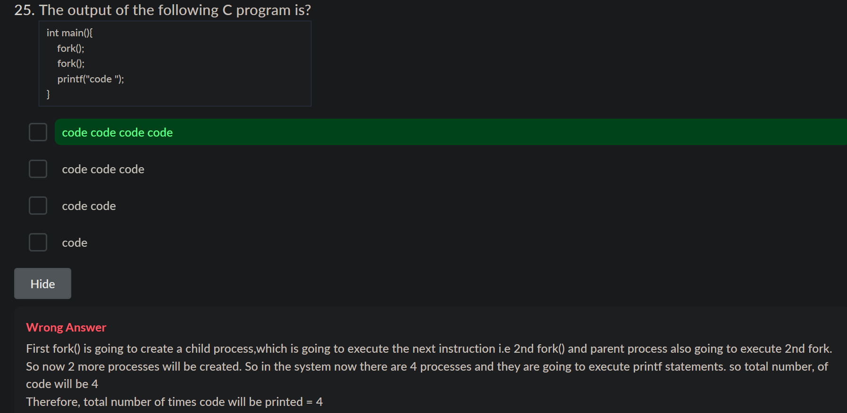



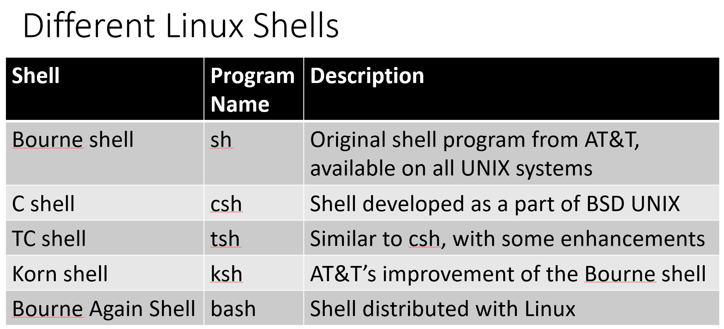

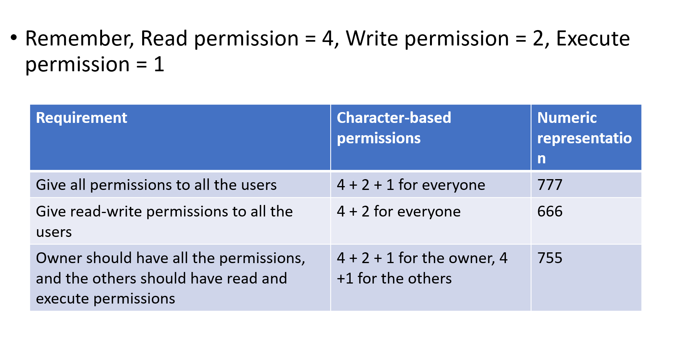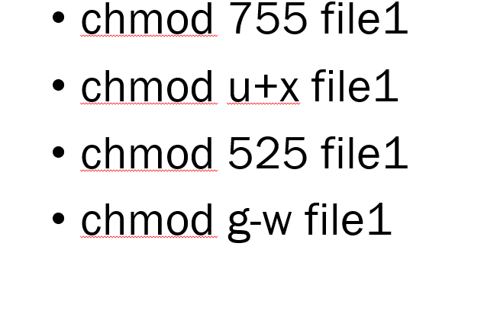

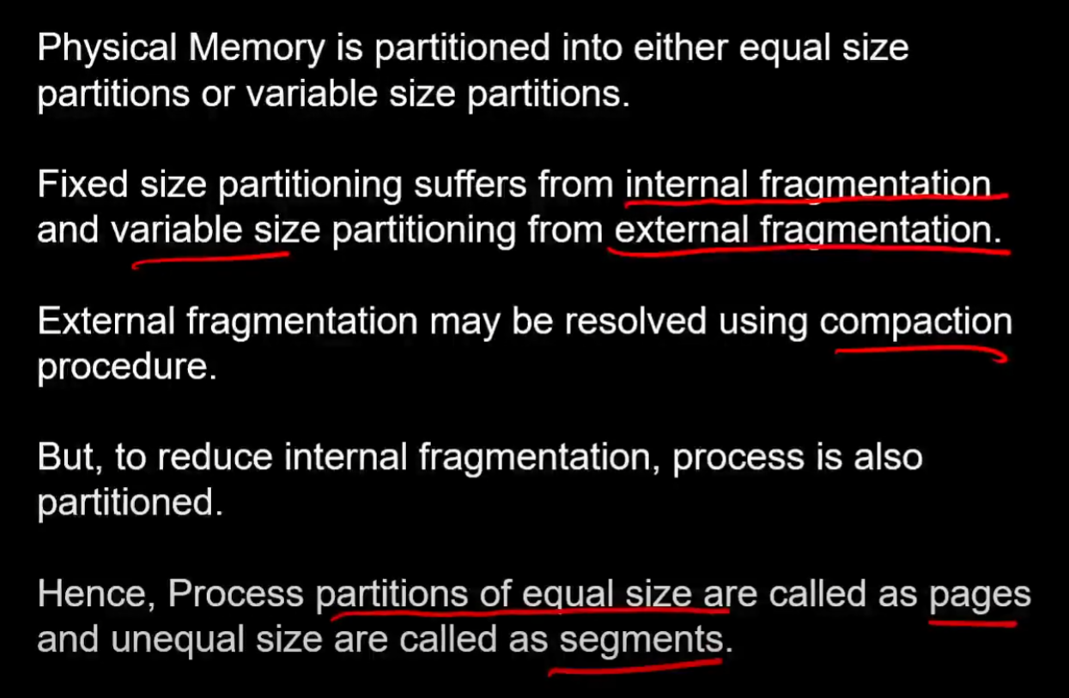

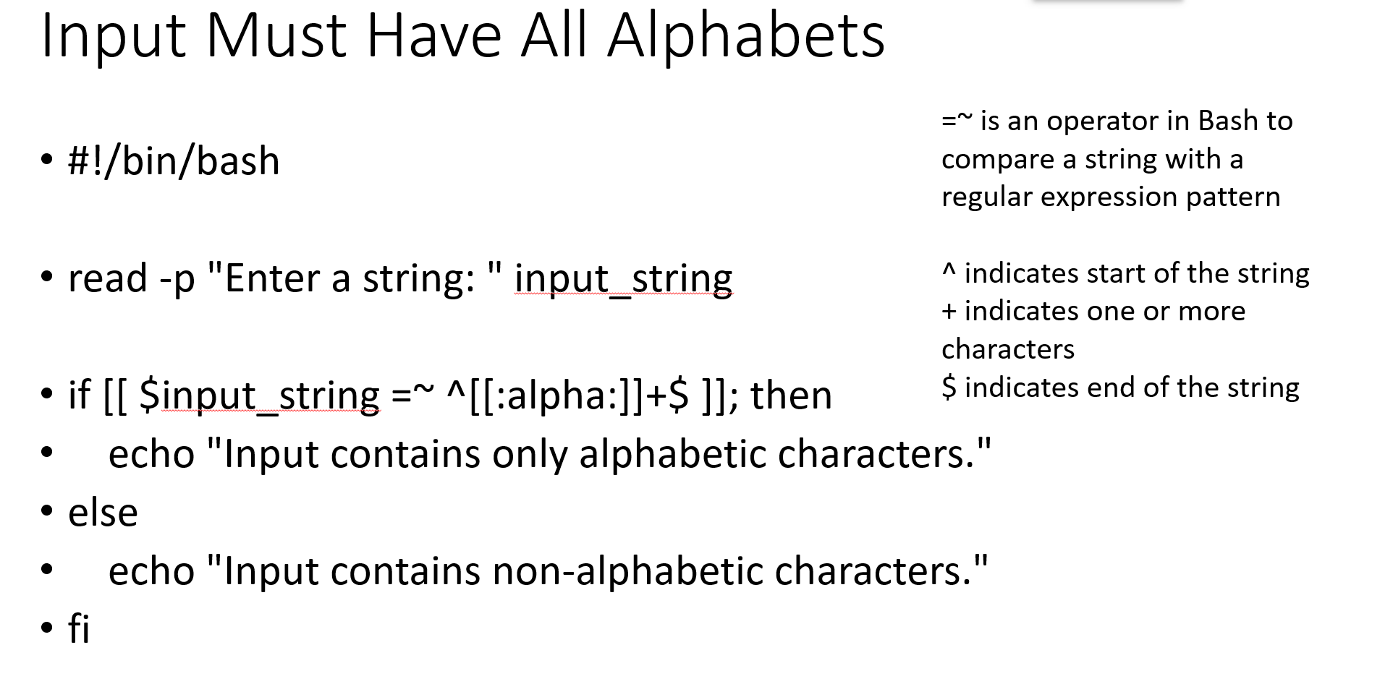

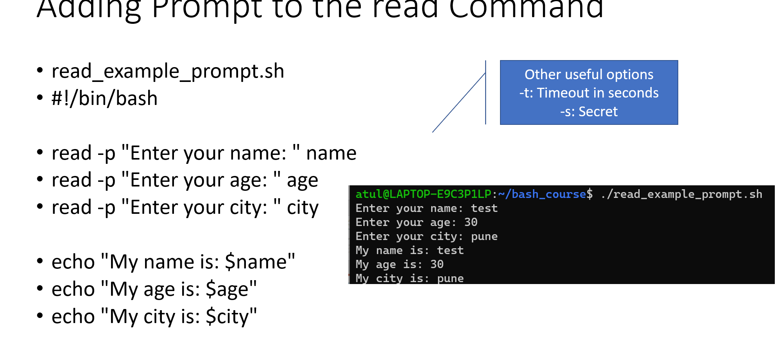

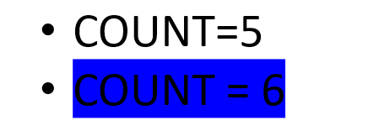 no spaces

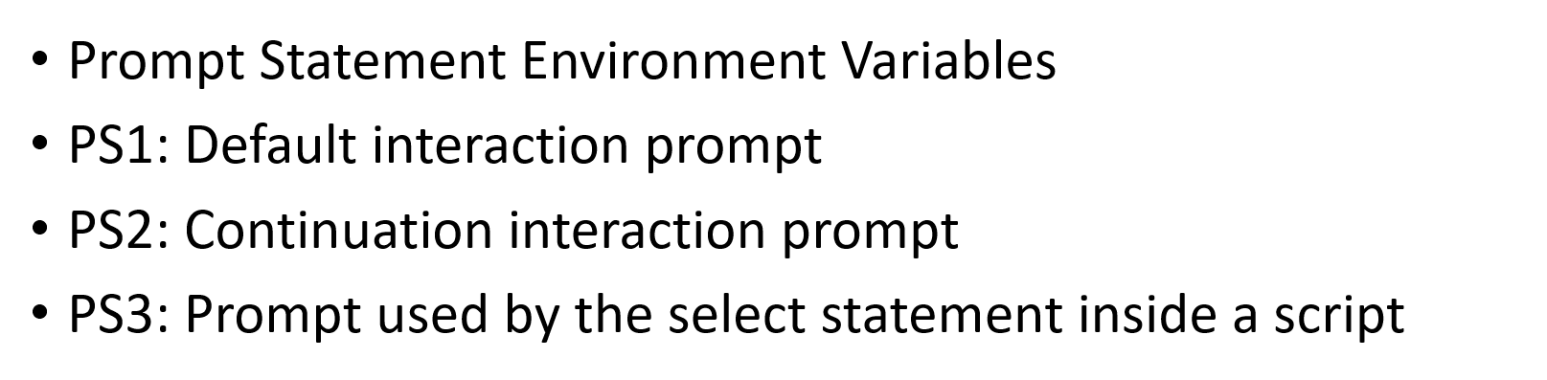

Long term scheduler 🡺 job scheduler

* It also controls the **degree of multiprogramming** (Number of new processes and departing processes).
* The primary objective of the job scheduler is to provide a balanced mix of jobs, such as I/O bound and processor bound.

**Short term scheduler 🡺** CPU scheduler or dispatcher 🡪 faster than long term

* It is in charge of moving a ready state process to the running state
* CPU scheduler selects process among the processes that are ready to execute and allocates CPU to one of them

**Medium term scheduler 🡺**

* Medium term scheduling is part of the swapping
* It reduces the degree of multiprogramming.
* medium term scheduler is in-charge of handling the swapped out-processes.

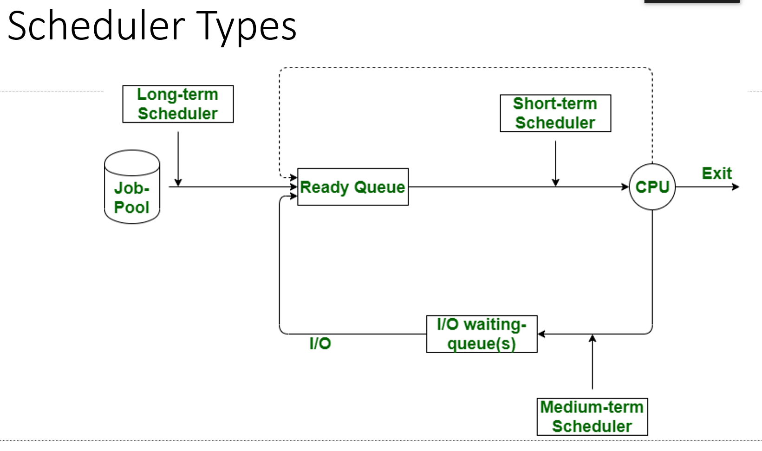

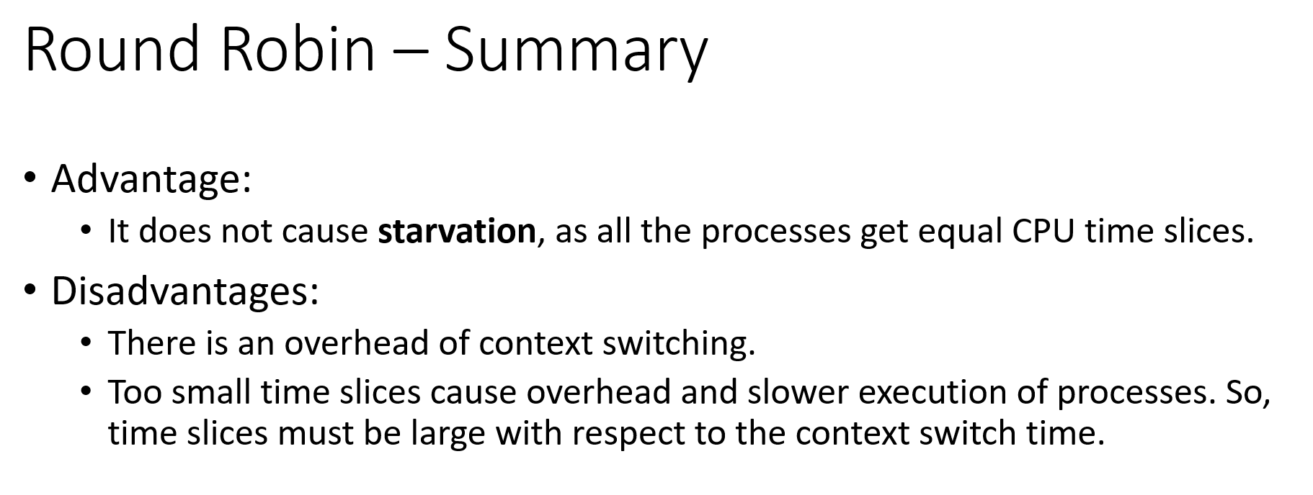

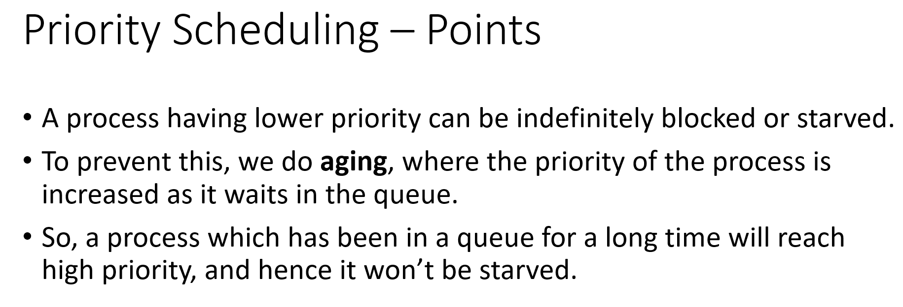

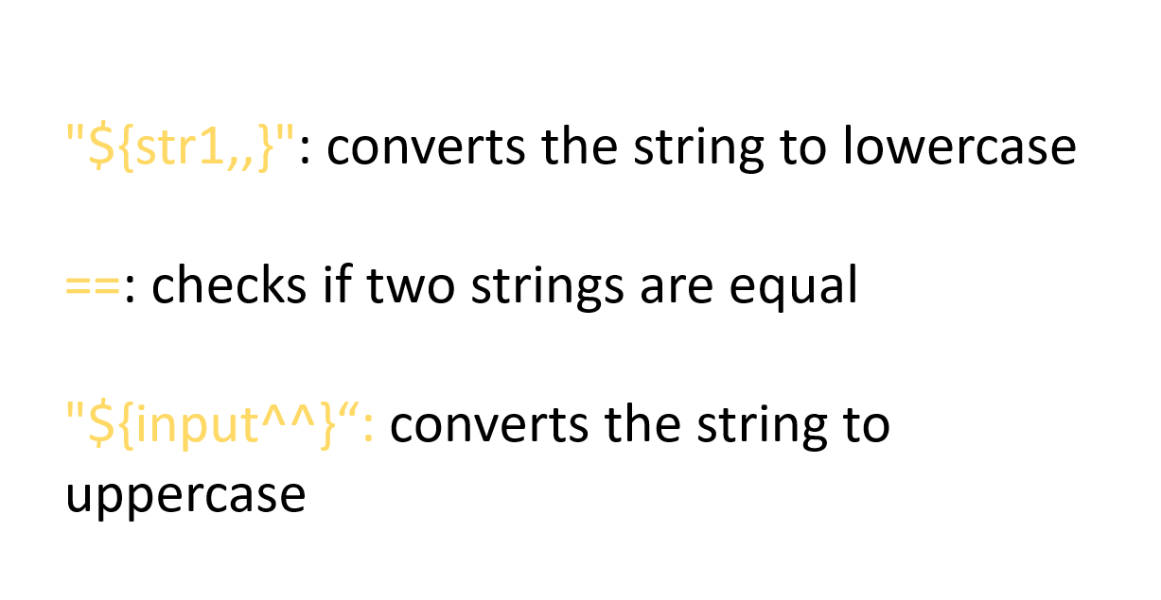

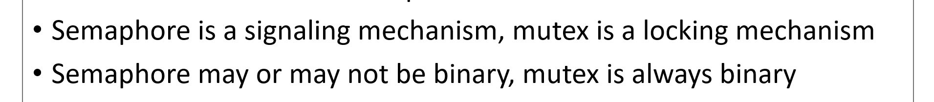

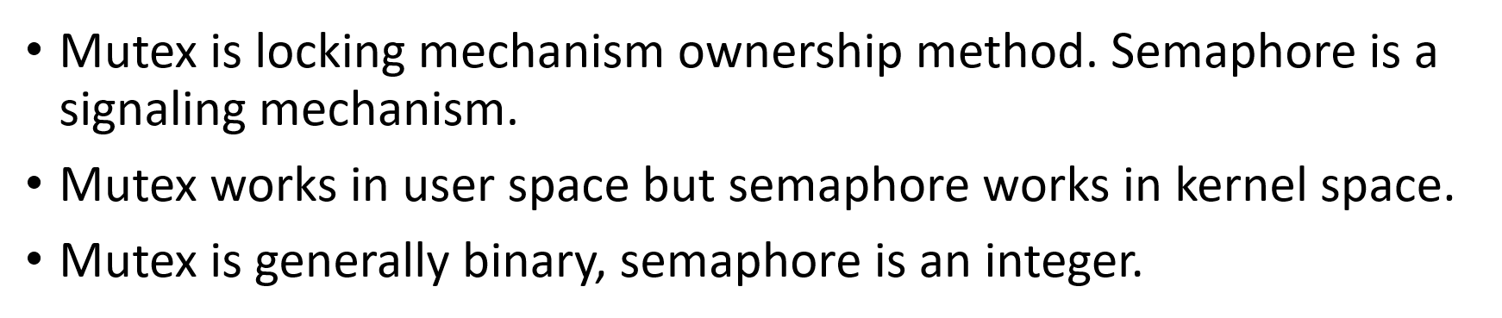

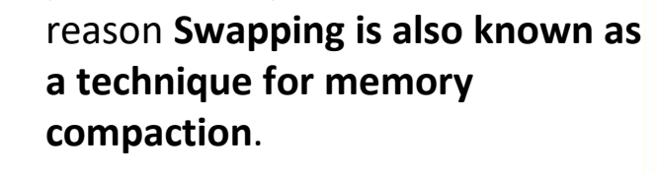

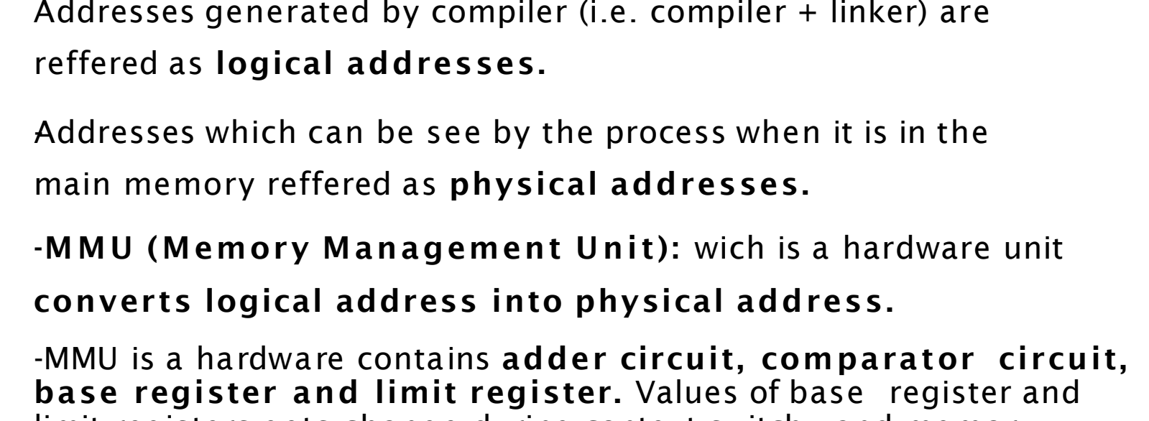

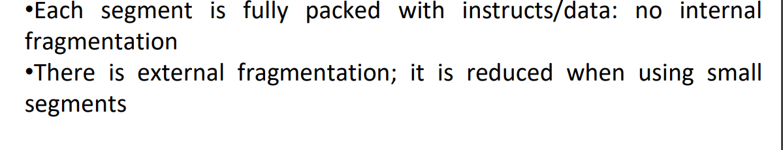

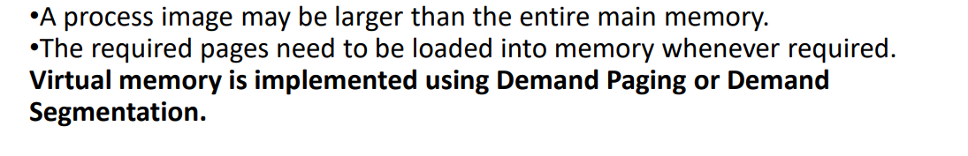

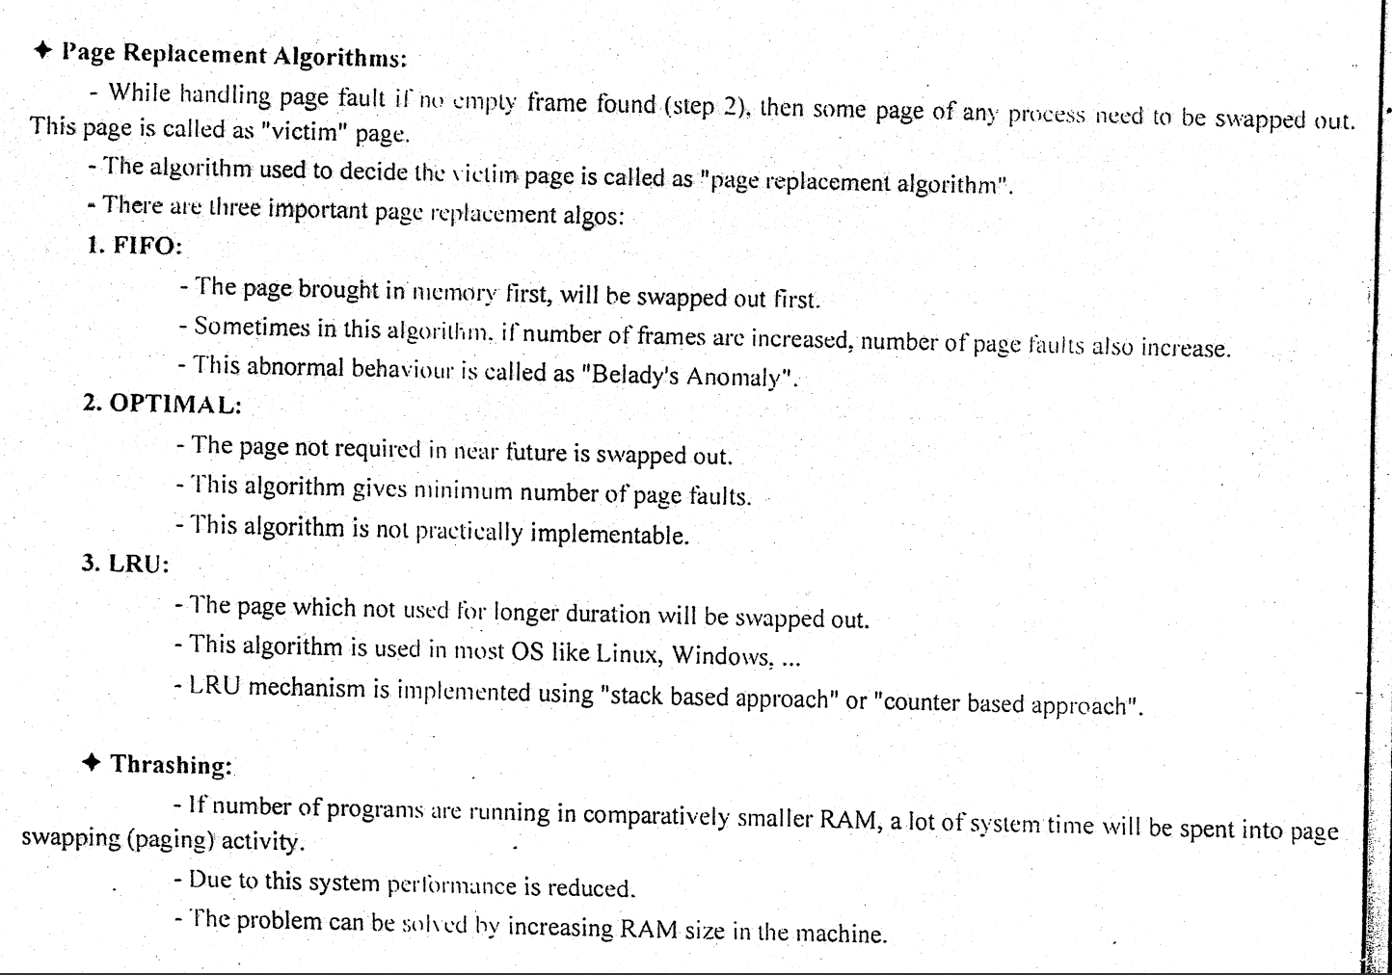

Mcq

Kernel generates signal to

* **notify processes of events**
* call user space
* ﻿﻿stop execution of ended process
* ﻿﻿Kernal does not generate signals

ChatGPT

Kernel generates **signals to notify processes of events.**

Which one of the following is not the part of main thread libraries in use today?

* POSIX Pthreads
* ﻿﻿Win32 threads
* ﻿﻿Java threads
* ﻿﻿**HPUX threads**

ChatGPT

HPUX threads are not part of the main thread libraries in use today.

Where is swap space located

* Primary Memory
* **Secondary Memory**
* ﻿﻿Registers
* ﻿﻿Virtual Memory

ChatGPT

Swap space is located in Secondary Memory.

Which of the following environment variable contains the value of default Shell Prompt?

* ﻿﻿PS1
* ﻿﻿PS2
* SHELL
* $HOME

ChatGPT

The environment variable containing the value of the default Shell Prompt is PS1.

Each process (in a process-model) has a :

* Single pending field
* ﻿﻿**Signal mask field**
* ﻿﻿Signal action activity
* ﻿﻿All of the above

ChatGPT

In a process model, each process has a Signal mask field.

Which of the following for loop declaration is not valid?

* ﻿﻿**for (int i = 99; i>= 0;i/9 )**
* ﻿﻿for (int i = 7; i < 77; i += 7)
* ﻿﻿for (int i = 20; i >= 2; —i)
* for (int i = 2; i<= 20; i = 2*i)

ChatGPT

The for loop declaration that is not valid is: **A**

Another type of multiple-CPU system is the:

* Mini Computer
* ﻿﻿Super Computer
* ﻿﻿**Clustered System**
* ﻿﻿Network Computer

ChatGPT

The correct option is: Clustered System

Logical extension of multiprogramming operating system is:

* Time sharing
* ﻿﻿Multi-tasking
* ﻿﻿Single programing
* ﻿﻿Time sharing and Multi-tasking

ChatGPT

The correct option is: The logical extension of multiprogramming operating systems is indeed both Time Sharing and Multi-tasking.

Signal delivery in a process model takes place:

* ﻿﻿in the context of the process that received the signal
* ﻿﻿in the context of the process that generated the signal
* ﻿﻿in the context of the kernel
* ﻿﻿None of the above

ChatGPT

Signal delivery in a process model takes place in the context of the process that received the signal.

Fill the blanks

* Secondary memory is divided into equal size partition (fixed) called ______ and main memory is divided into small fixed-sized blocks of (physical) memory called _____

ChatGPT

Secondary memory is divided into equal size partitions (fixed) called pages, and main memory is divided into small fixed-sized blocks of (physical) memory called frames.

Which one is fastest form of Inter-process communication (IPC)?

* ﻿﻿Signals
* ﻿﻿Shared Memory
* ﻿﻿Message Queues
* ﻿﻿Pipes

ChatGPT

The fastest form of Inter-process communication (IPC) is usually considered to be Shared Memory.

______ involves storing the context or state of a process so that it can be reloaded when required and execution can be resumed from the same point as earlier.

* ﻿﻿Process Switching
* ﻿﻿Context Switching
* ﻿﻿Process Swapping
* ﻿﻿Context Swapping

ChatGPT

The correct term is Context Swapping.

I think it is context switching

ChatGPT

Apologies for the confusion. You are correct. The correct term is Context Switching.

Which of the following should surround regular expressions to ensure that they are processed properly?

• Parentheses

• **Backslashes**

• Double quotation marks

• Single quotation marks

ChatGPT

Regular expressions are typically surrounded by slashes (/) to ensure they are processed properly. For example: /pattern/.

Can we have multiple main methods in java program

ChatGPT

No, a Java program can only have one main method. The main method is the entry point of a Java program, and having multiple main methods would create ambiguity about which one to execute.

Which is incorrect?

* ﻿﻿Every class must contain a main() method.
* ﻿﻿Applets do not require a main() method at all.
* ﻿﻿There can be only one main() method in a program.
* ﻿﻿main() method must be made public.

ChatGPT

"Every class must contain a main() method" is incorrect. Not every class in Java needs to have a main() method. Only the class containing the main entry point of the program needs a main() method. Other classes may or may not have it, depending on their purpose in the program.

A dirty bit or modified bit is a bit that is associated with a block of computer memory and indicates whether or not the corresponding block of memory has been modifled. When the dirty bit is switched

_____, the page is modified and can be replaced in memory. If it is ______, no replacement is necessary since no updates have been made.

ChatGPT

When the dirty bit is switched ON, the page is modified, and it can be replaced in memory. If it is switched OFF, no replacement is necessary since no updates have been made.

Which of the following signals cannot be blocked, ignored and caught?

* ﻿﻿SIGINT SIGSTOP
* ﻿﻿SIGINT SIGKILL
* ﻿﻿SIGINT SIGILL
* ﻿﻿SIGKILL SIGSTOP

ChatGPT

The signals SIGKILL and SIGSTOP cannot be blocked, ignored, or caught.

What value is returned by the fork() system call on a successful creation of the child process to the child?

* 0
* -1
* 1
* Pid of parent

ChatGPT

The fork() system call returns 0 to the child process.

A graphical operating system- Windows NT, developed by Microsoft uses ____ type of kernel?

* ﻿﻿Monolithic
* ﻿﻿Micro
* ﻿﻿**Hybrid**
* ﻿﻿Nano

ChatGPT

Windows NT, developed by Microsoft, uses a Hybrid type of kernel.

The command used to display long listing of file is:

ChatGPT

The command used to display a long listing of files is: **ls -l**

Which of the following variable need to be initialized before using it?

* ﻿﻿Local
* ﻿﻿Instance
* ﻿﻿Static
* ﻿﻿Global

ChatGPT

All variables, whether local, instance, static, or global, need to be initialized before using them to ensure they have valid values.

Which of the following represent legal flow control statements?

* ﻿﻿continue(inner):
* ﻿﻿break():
* ﻿﻿**break**;
* ﻿﻿exit();

ChatGPT

Among the options provided, the legal flow control statement is break;. The correct syntax for breaking out of a loop or switch statement in many programming languages includes the break keyword followed by a semicolon.

Memory management technique in which Operating System stores and retrieves data from secondary storage for use in main memory is called ____

ChatGPT

The memory management technique in which the operating system stores and retrieves data from secondary storage for use in main memory is called paging.

Consider a single level paging scheme. The virtual address space is 4 MB and page size is 4

KB. What could be the number of pages of process here?

ChatGPT

Given that the virtual address space is 4 MB and the page size is 4 KB, you can calculate the number of pages using the formula:

Number of Pages = Virtual Address Space / Page Size

Substitute the values:

Number of Pages = 4 MB / 4 KB

First, convert both the virtual address space and page size to the same unit (either KB or MB):

4 MB = 4 * 1024 KB

Now calculate:

Number of Pages = (4 * 1024 KB) / 4 KB

Number of Pages = 1024

Therefore, the number of pages for the process in this single-level paging scheme is 1024.